Download the android sdk for android version 9 from Android sdk manager

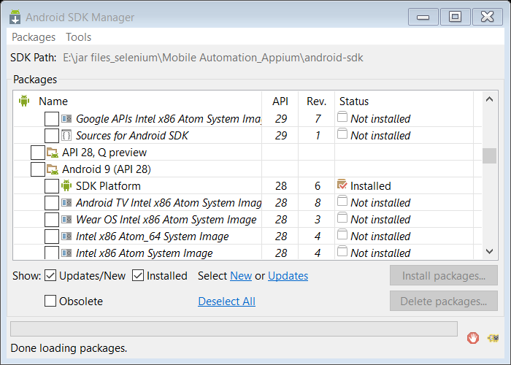

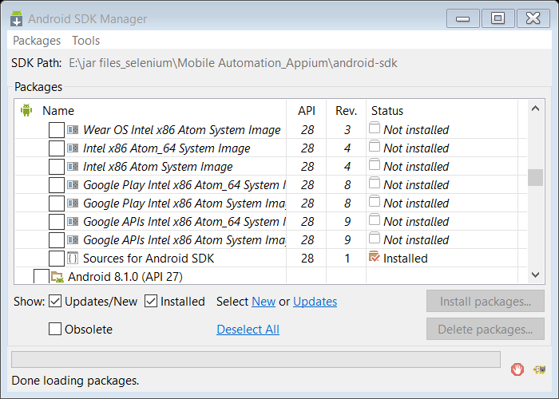

Android debug machine – give the path of the adb file under the path variable for platform -tools

E:\jar files_selenium\Mobile Automation_Appium\android-sdk\platform-tools under the system variables under the path section

Run adb from command prompt

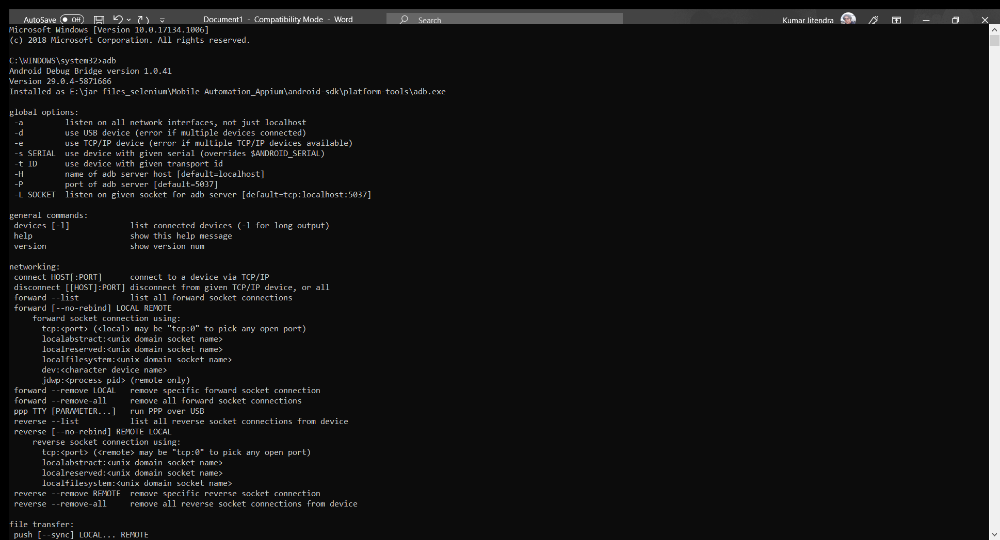

Give the path of build tool

E:\jar files_selenium\Mobile Automation_Appium\android-sdk\build-tools under the path variable (under the System variables)

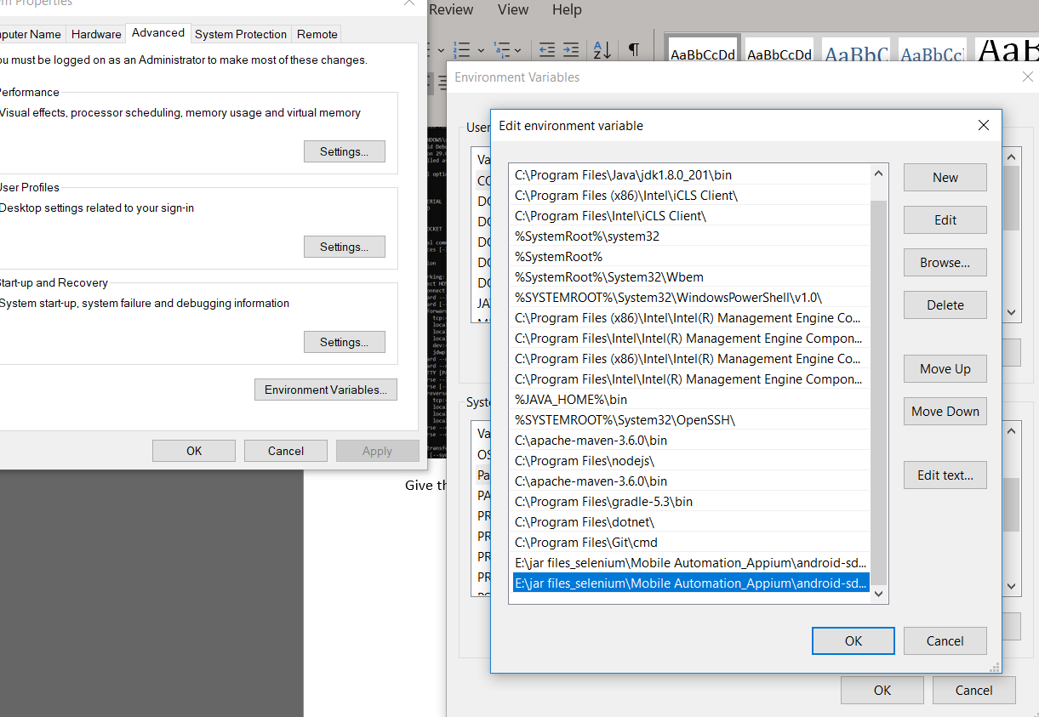

Click on 7times – for build (about phone) – to become developer

Once we become developer go to phone >system>developer options will be seen>

Enable usb debugging > click on always allow >

After that type adb devices

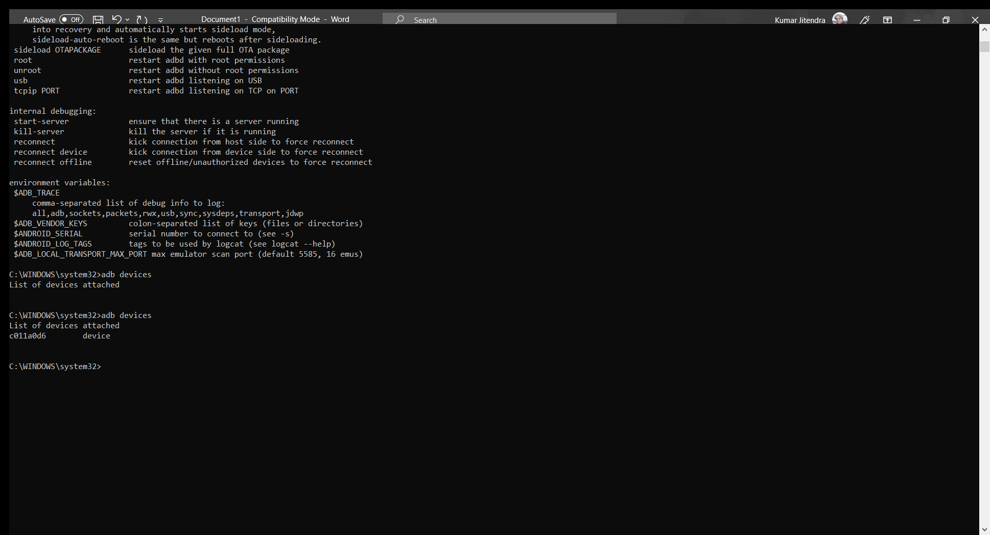

Set ANDROID_HOME variable under the system variable

Click on new System variable

To see the ANDROID_HOME path

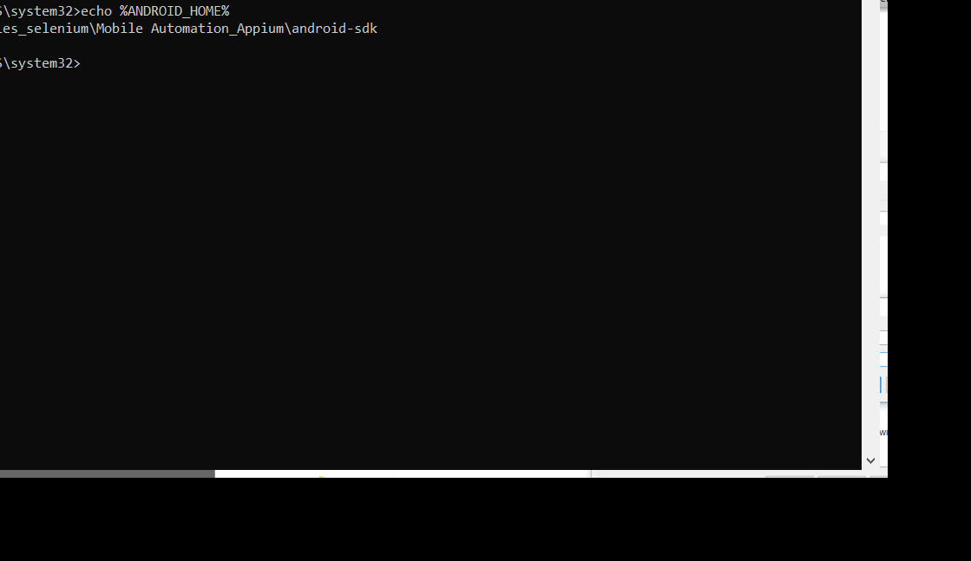

Connected two devices

Adb install

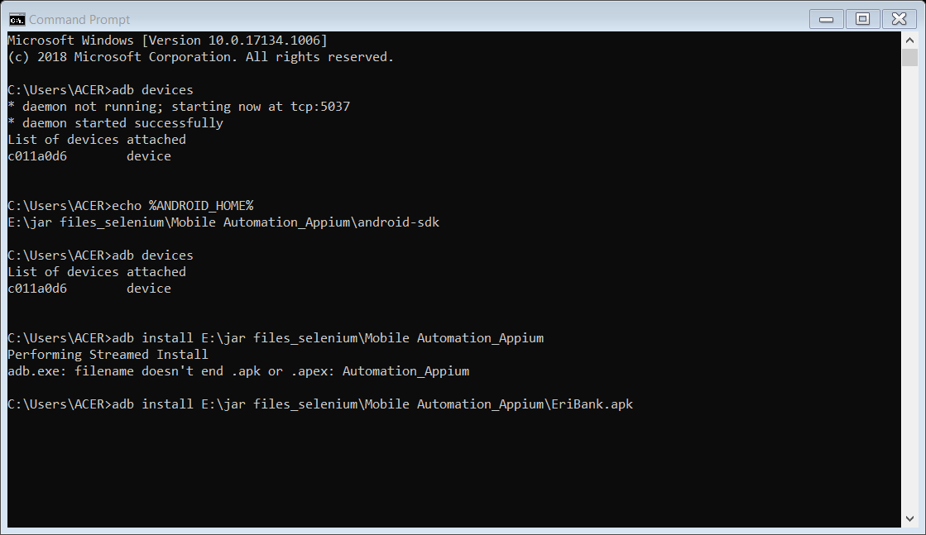

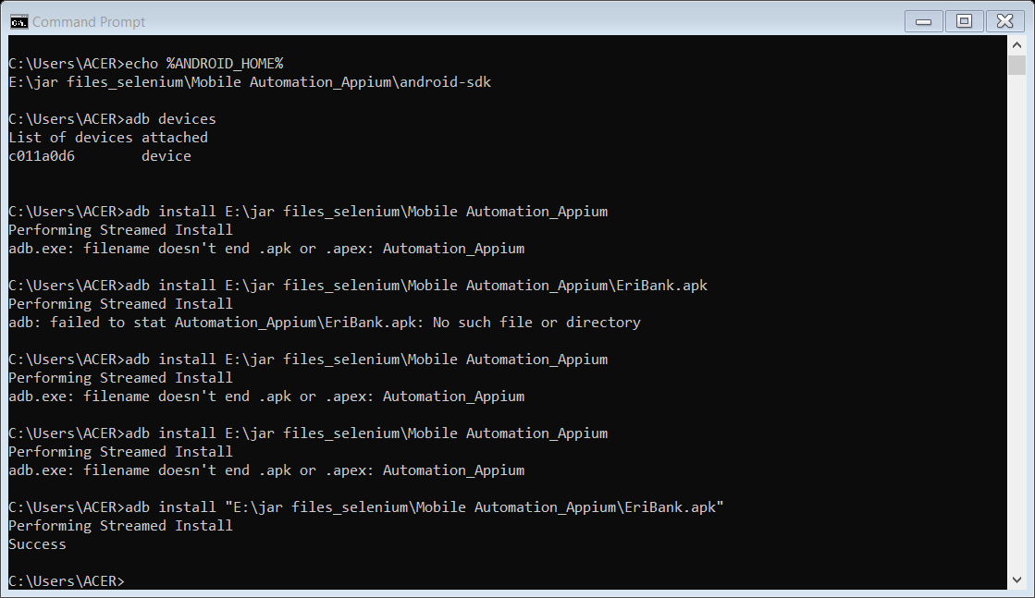

To run the package name and get the feature name

If the file name is having space then give the path of the file within “ ”

Gibe the path of the aapt dump badging “give the path of the EriBank.apk file “ and download the package name details under the E drive

Details .txt file it will have the package name and feature name



Details.txt file will be downloaded at the E drive 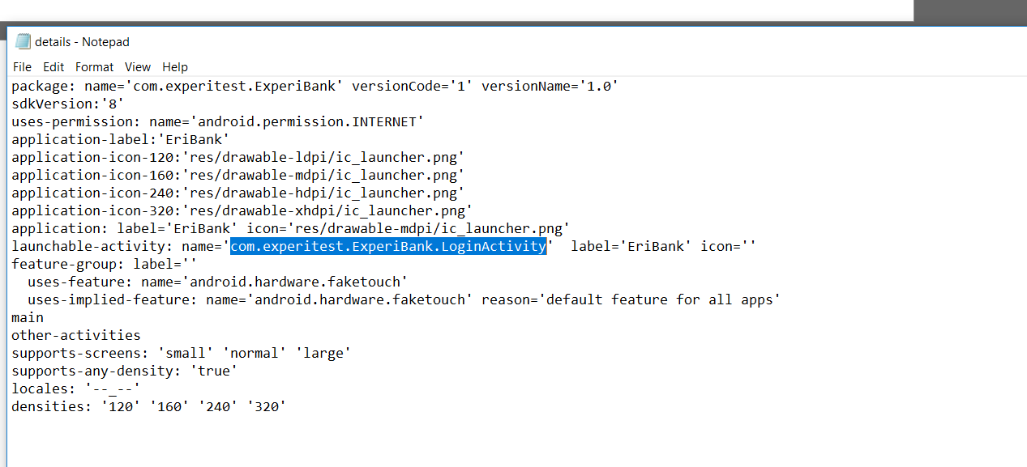

Get the package name and the feature name

Demo command

adb shell am start -n <PackageName>/<LaunchActivity>

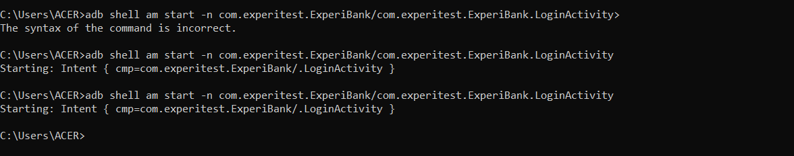



Srart the server of Appium

Click on Inspect

Give the path of the EriBank.apk file path

E:\jar_files_selenium\Mobile Automation_Appium\EriBank.apk

Click on Plus symbol – give the name of the package name which is present under Details.txt file

Add – app activity -./LognActivity

Save the session

automationName = give value as UiAutomator2

Add platformName = Android

Click on start session

Appium server is Up and Running

Search using id

Send keys

Npm – node js registry (npm is package installer )

npm install appium

all the programs form npm registry will go to the (node modules )

Run time Environment to run the java script programs

Change the directory file to D drive where all the node packages will be installed

Create new folder inside D drive

D:\npm_installation\node_modules

Go the folder path using command prompt

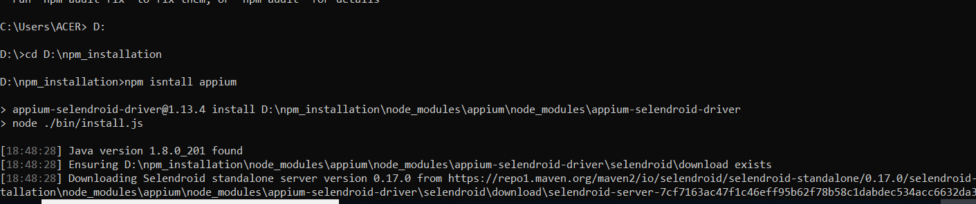

Now type the following command – npm install appium

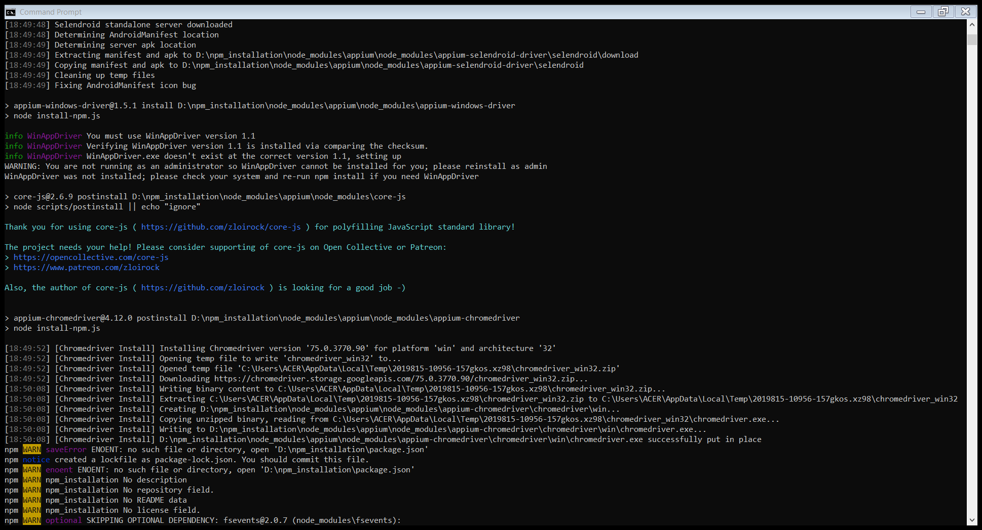

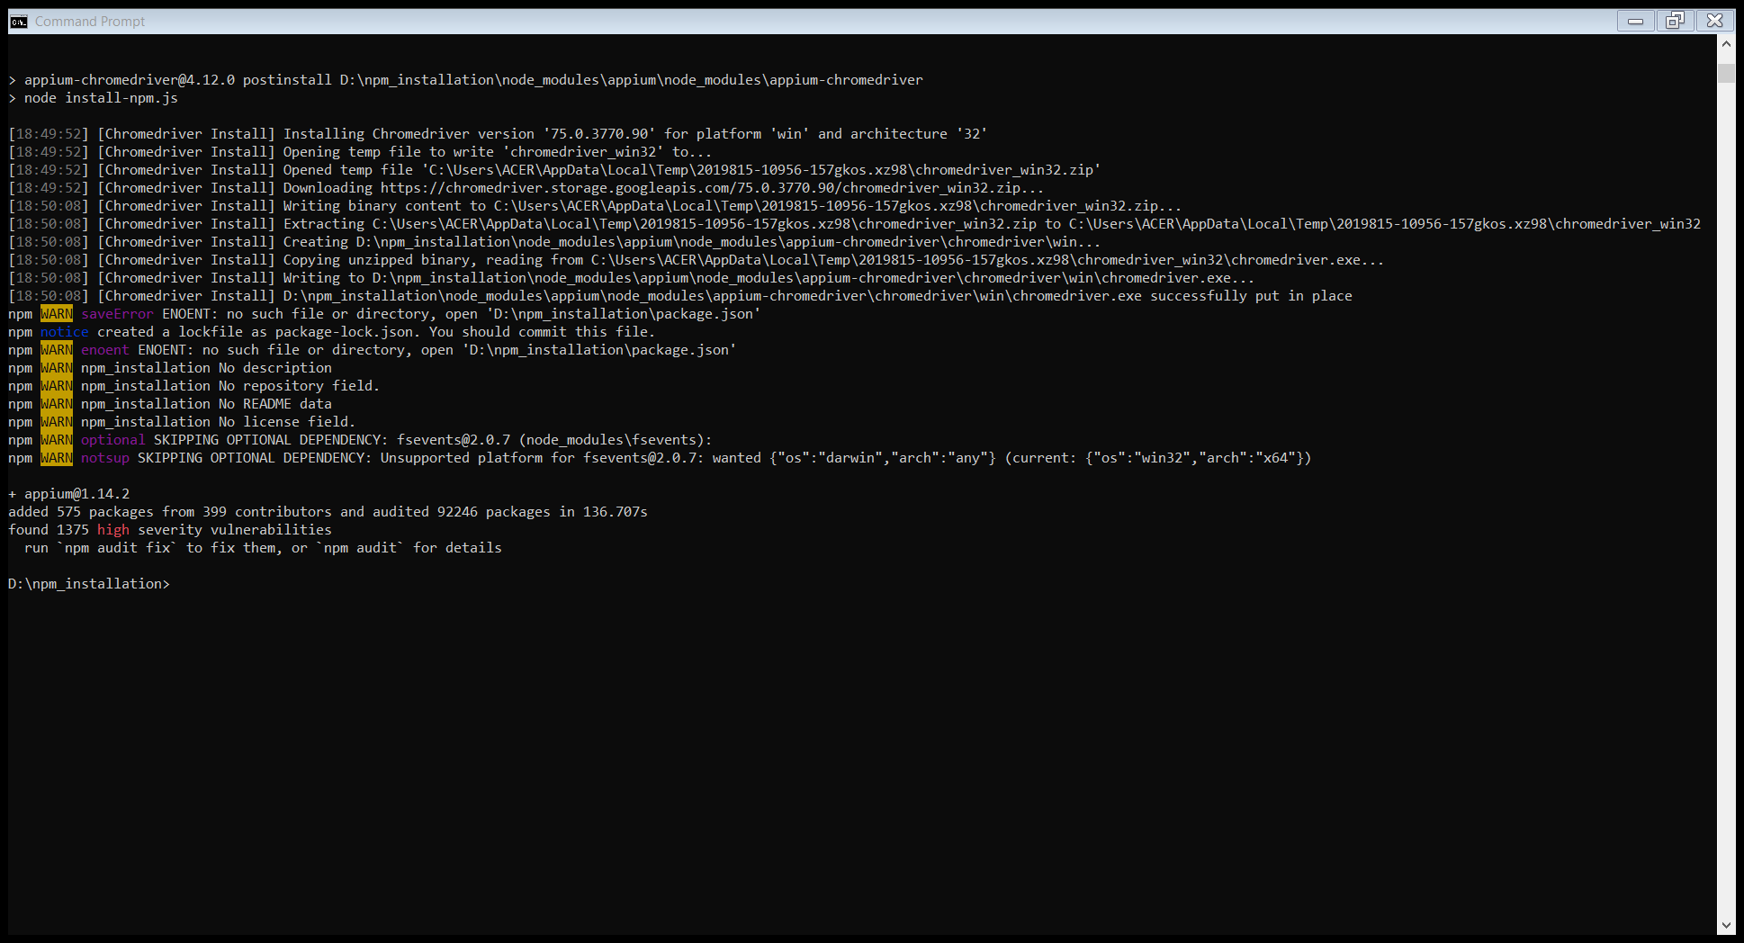

How to do global install for npm

Command – npm install -g appium

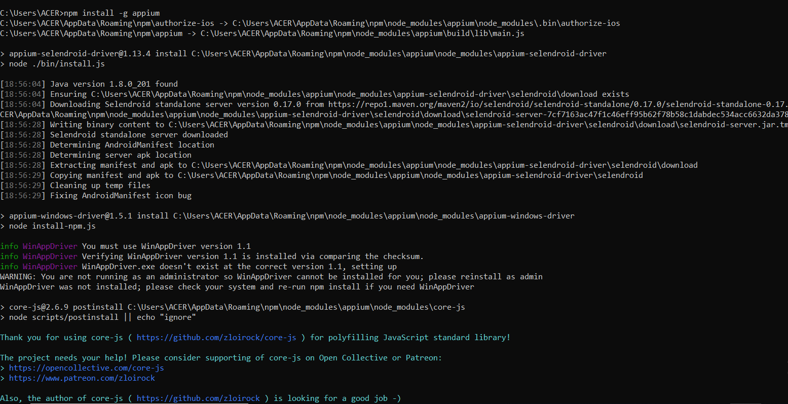

To run the appium server

Type appium from any directory as the appium server is installed globally

To start the appium server default (it will give default IP Address)

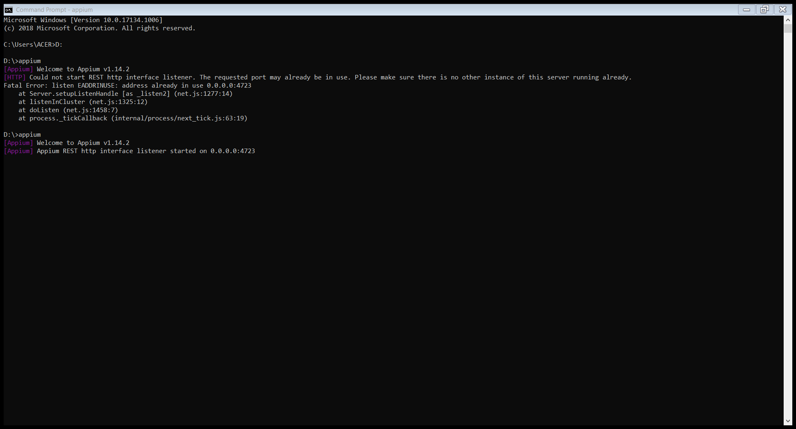

appium –adress localhost --port 4730

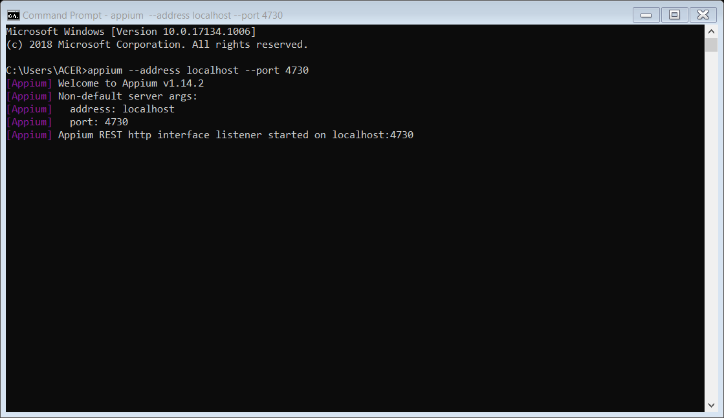

To see the local host server

Now at the code comment the server url code

Change the url to the local host to 127.0.0.1

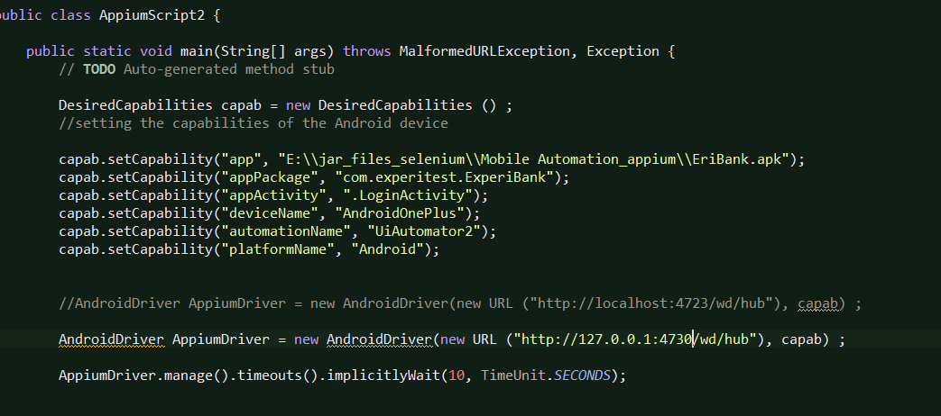

For the server give the IP4 address –

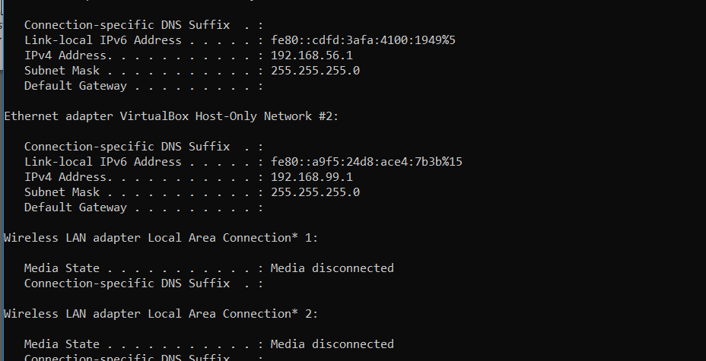

Give the IP address of the server as well as the port hub

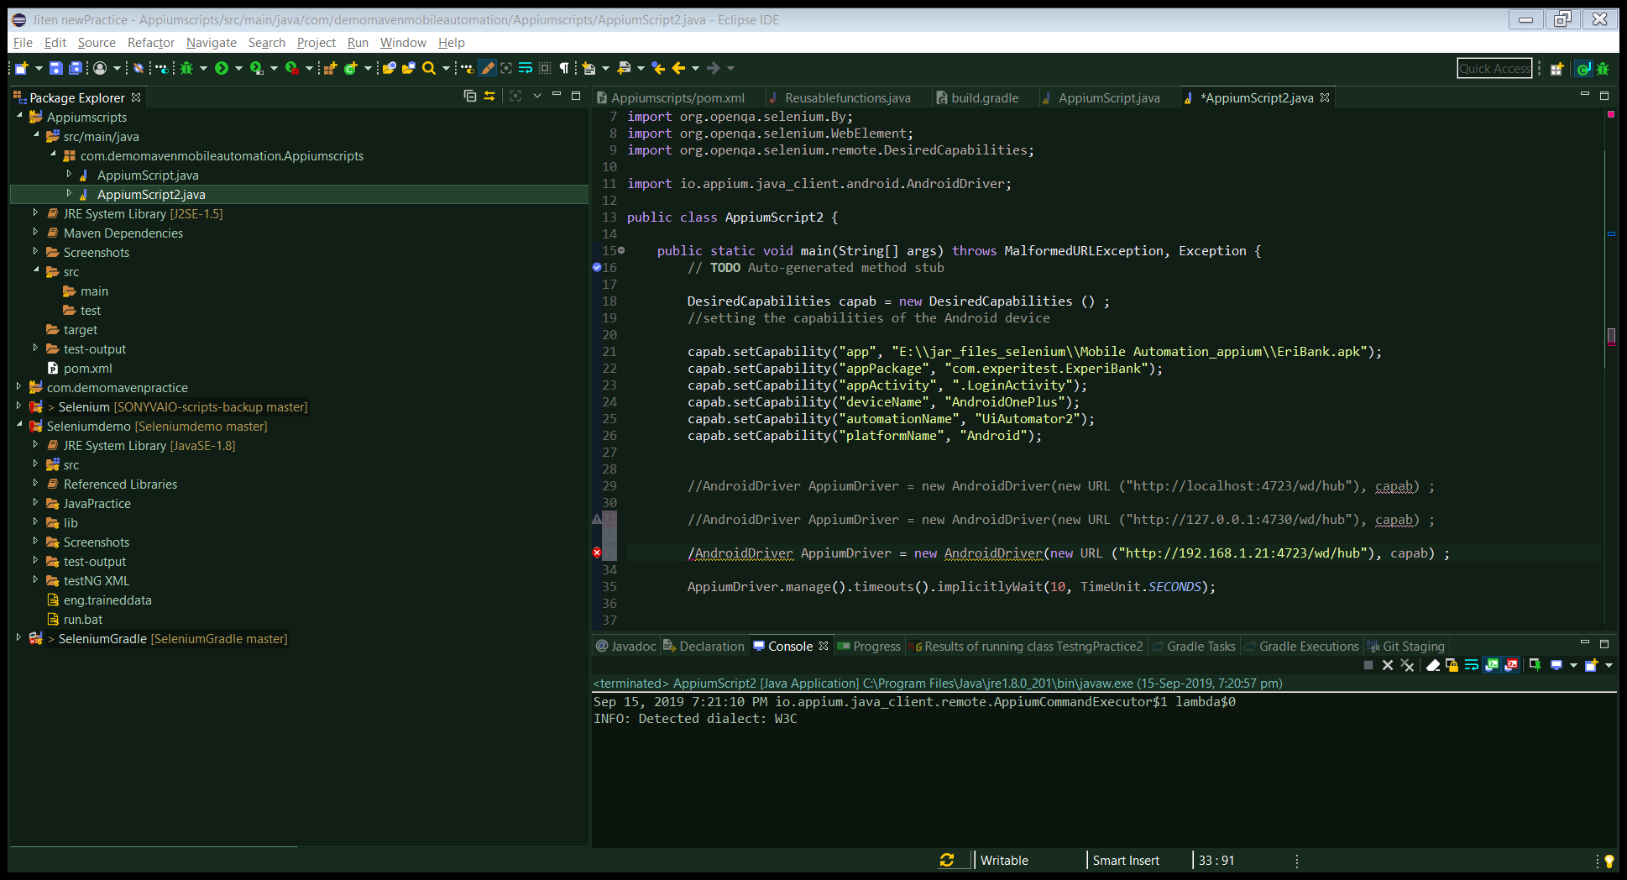

Select new Environmnent variables under system variables

Java compile setup for maven project

To run as a compiler through maven

Set the java build path to jdk 1.8

Windows >preferences>java > java buld compiler

Addthe jdk path

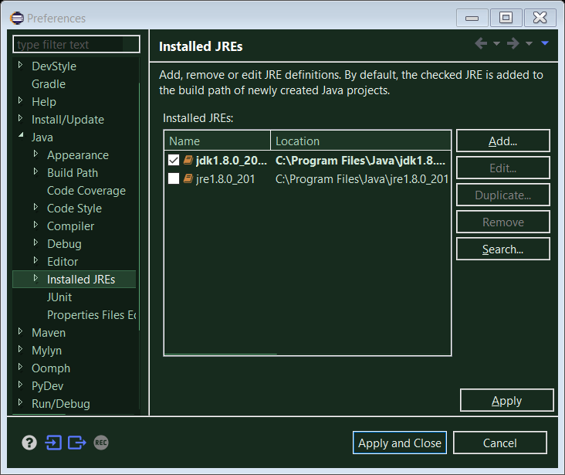

Select jdk

Run as Maven build > give goal as compile

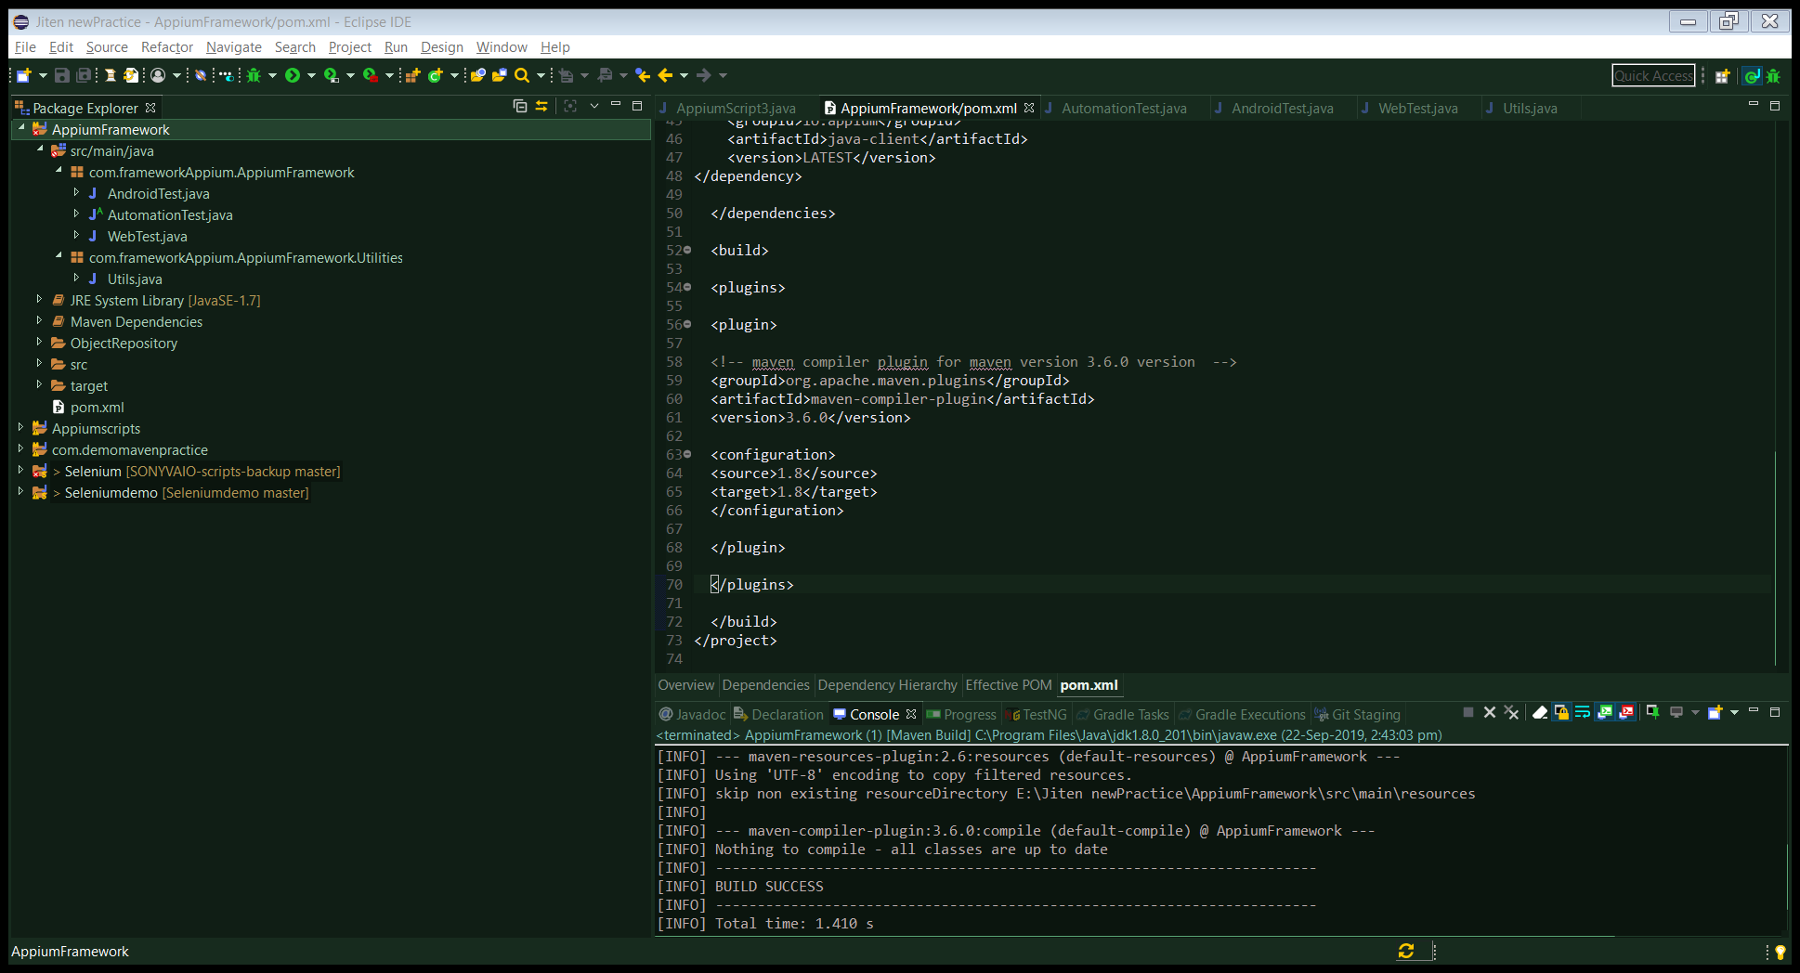

Maven as compilation tool

Go to the target folder under the maven project file – it will create .CLASS file which maven has compiled - .CLASS file is not readable

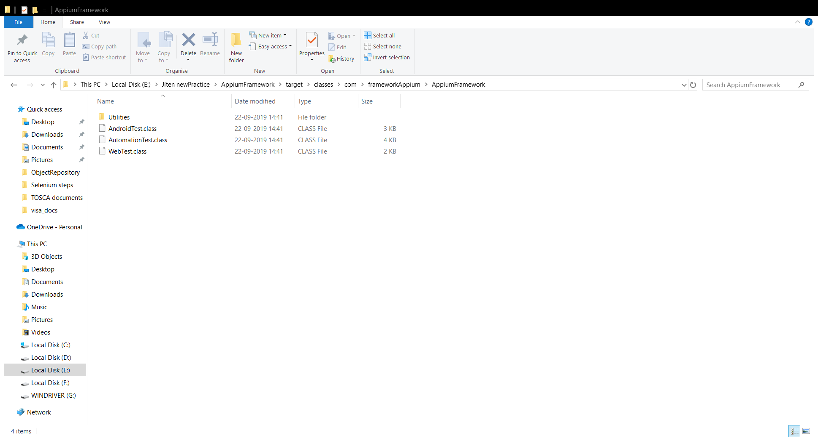

Now add dependency of maven jar file

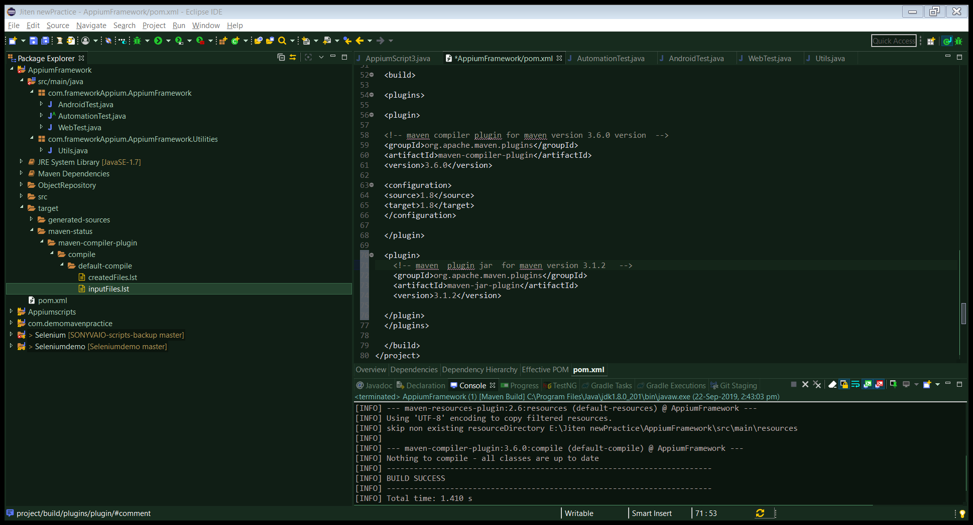

Mvn repository – this is the dependency to add the maven pluggin jar file

Manifest file in the jar file – it will have all the project dependency path

Run mvn package

It will create jar files at the target folder

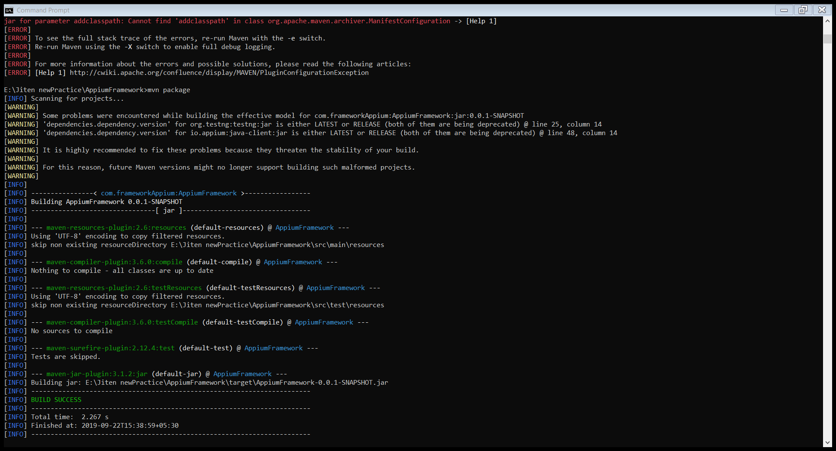

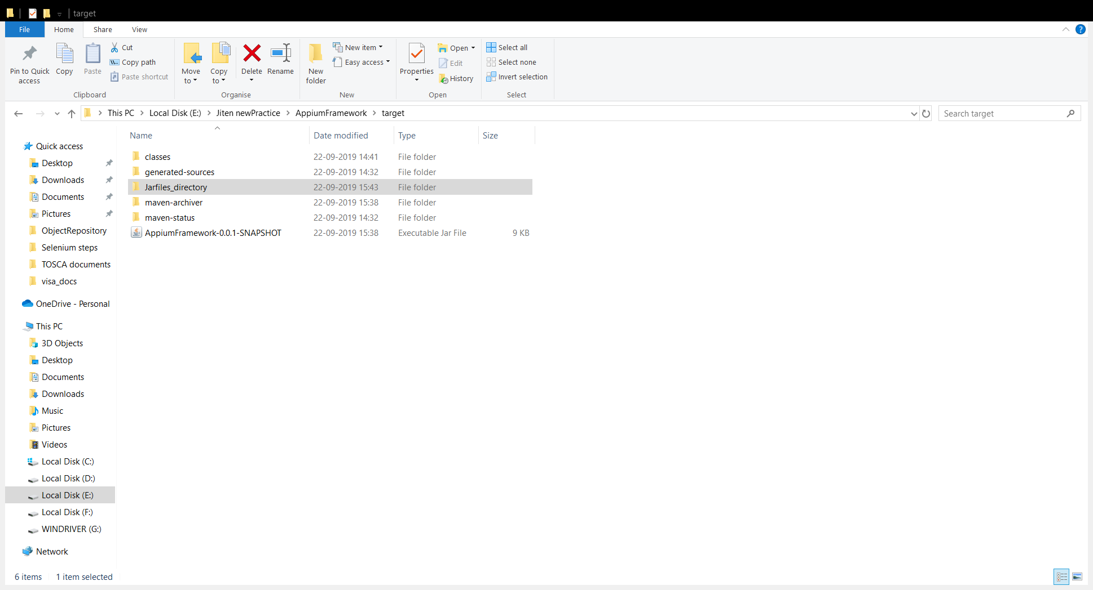

Jar file will be created

Now extract the jar files and put it inside the blank directory

Command to run

E:\Jiten newPractice\AppiumFramework\target\Jarfiles_directory>jar -xf "E:\Jiten newPractice\AppiumFramework\target\AppiumFramework-0.0.1-SNAPSHOT.jar"

It will create manifest file under the blank directory

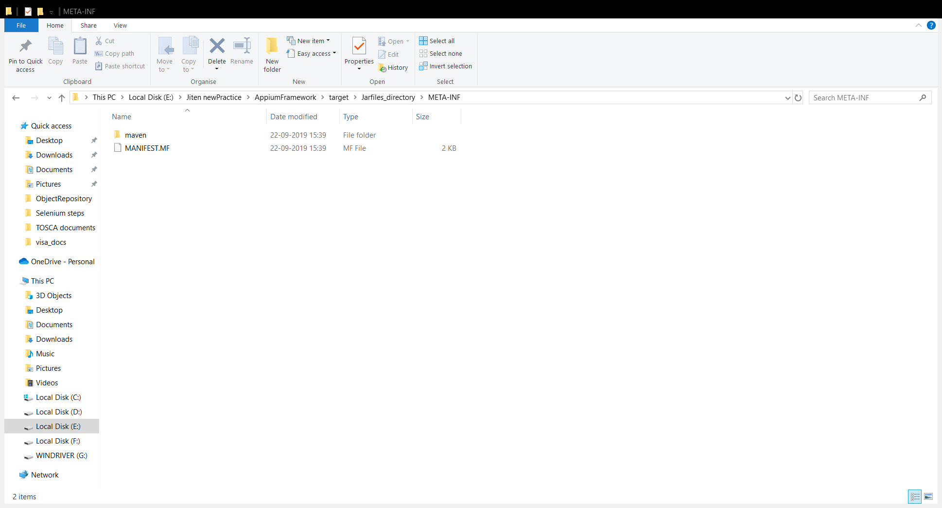

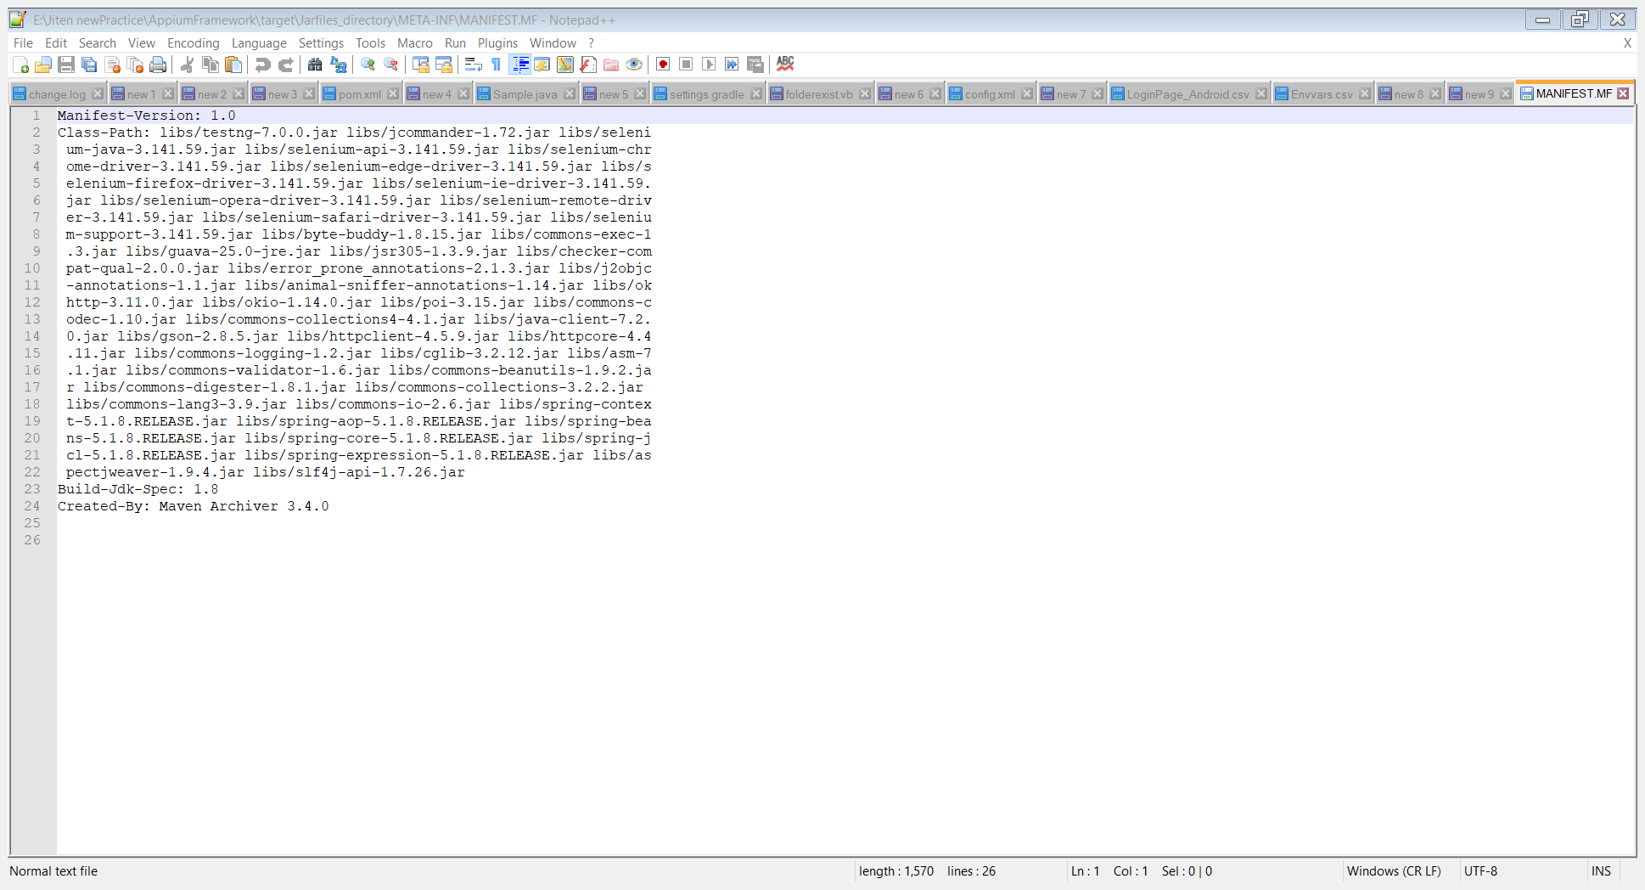

Open the manifest files

Copy dependencies path

Add the dependency plugin for copy

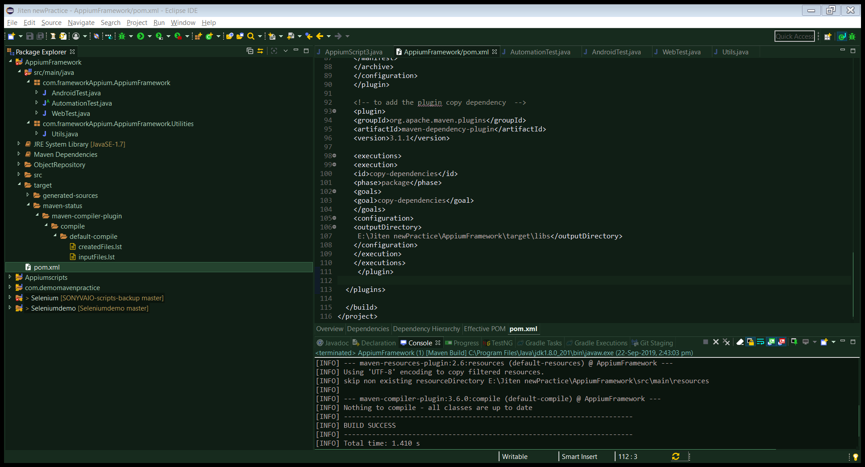

Give the target folder path where the dependencies would be stored

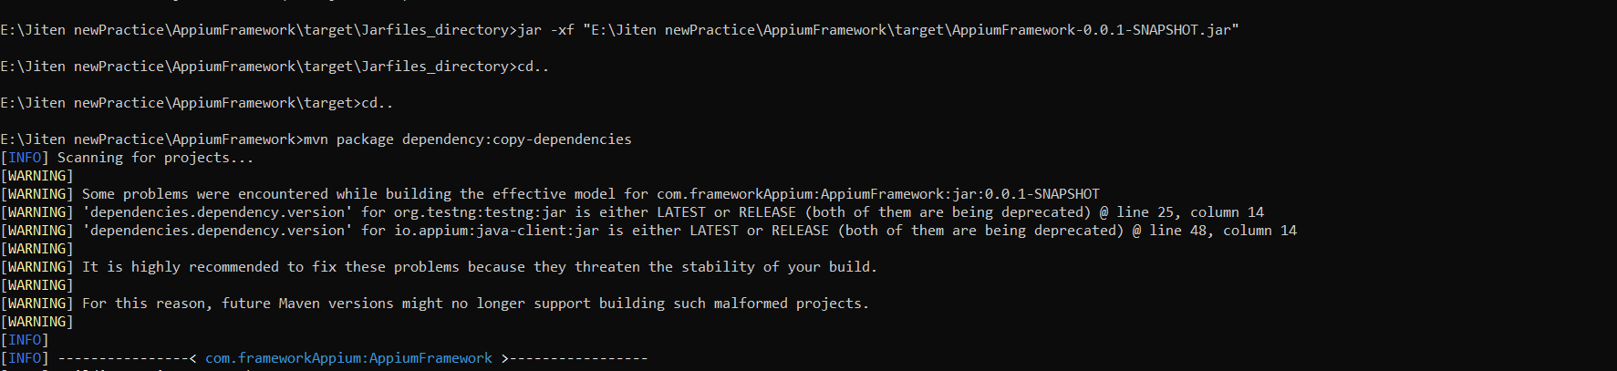

Dependency will be copied under the target folder path

E:\Jiten newPractice\AppiumFramework\target\libs

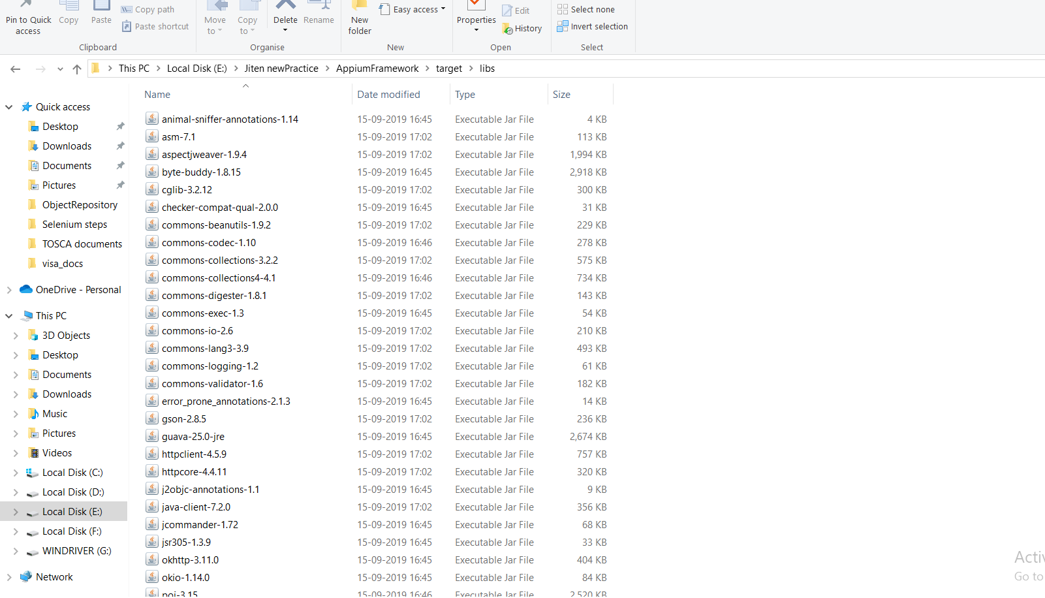

To download the maven parent folder path :-

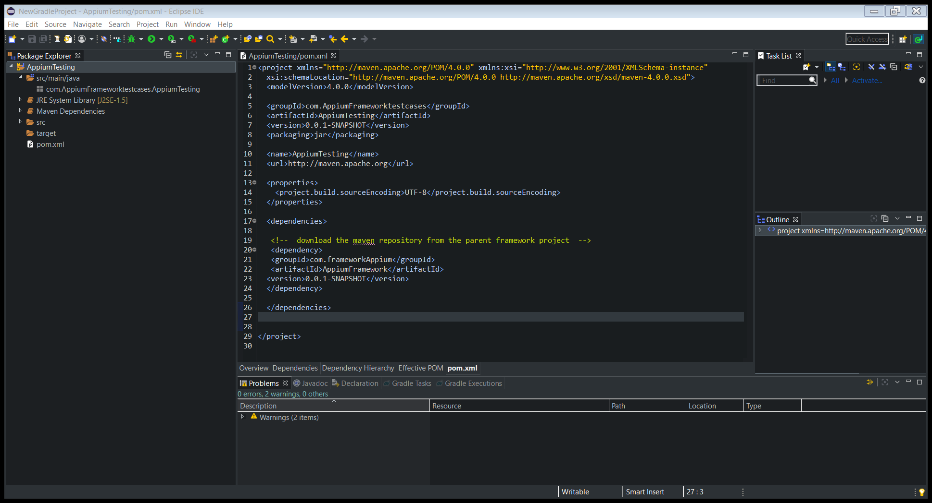

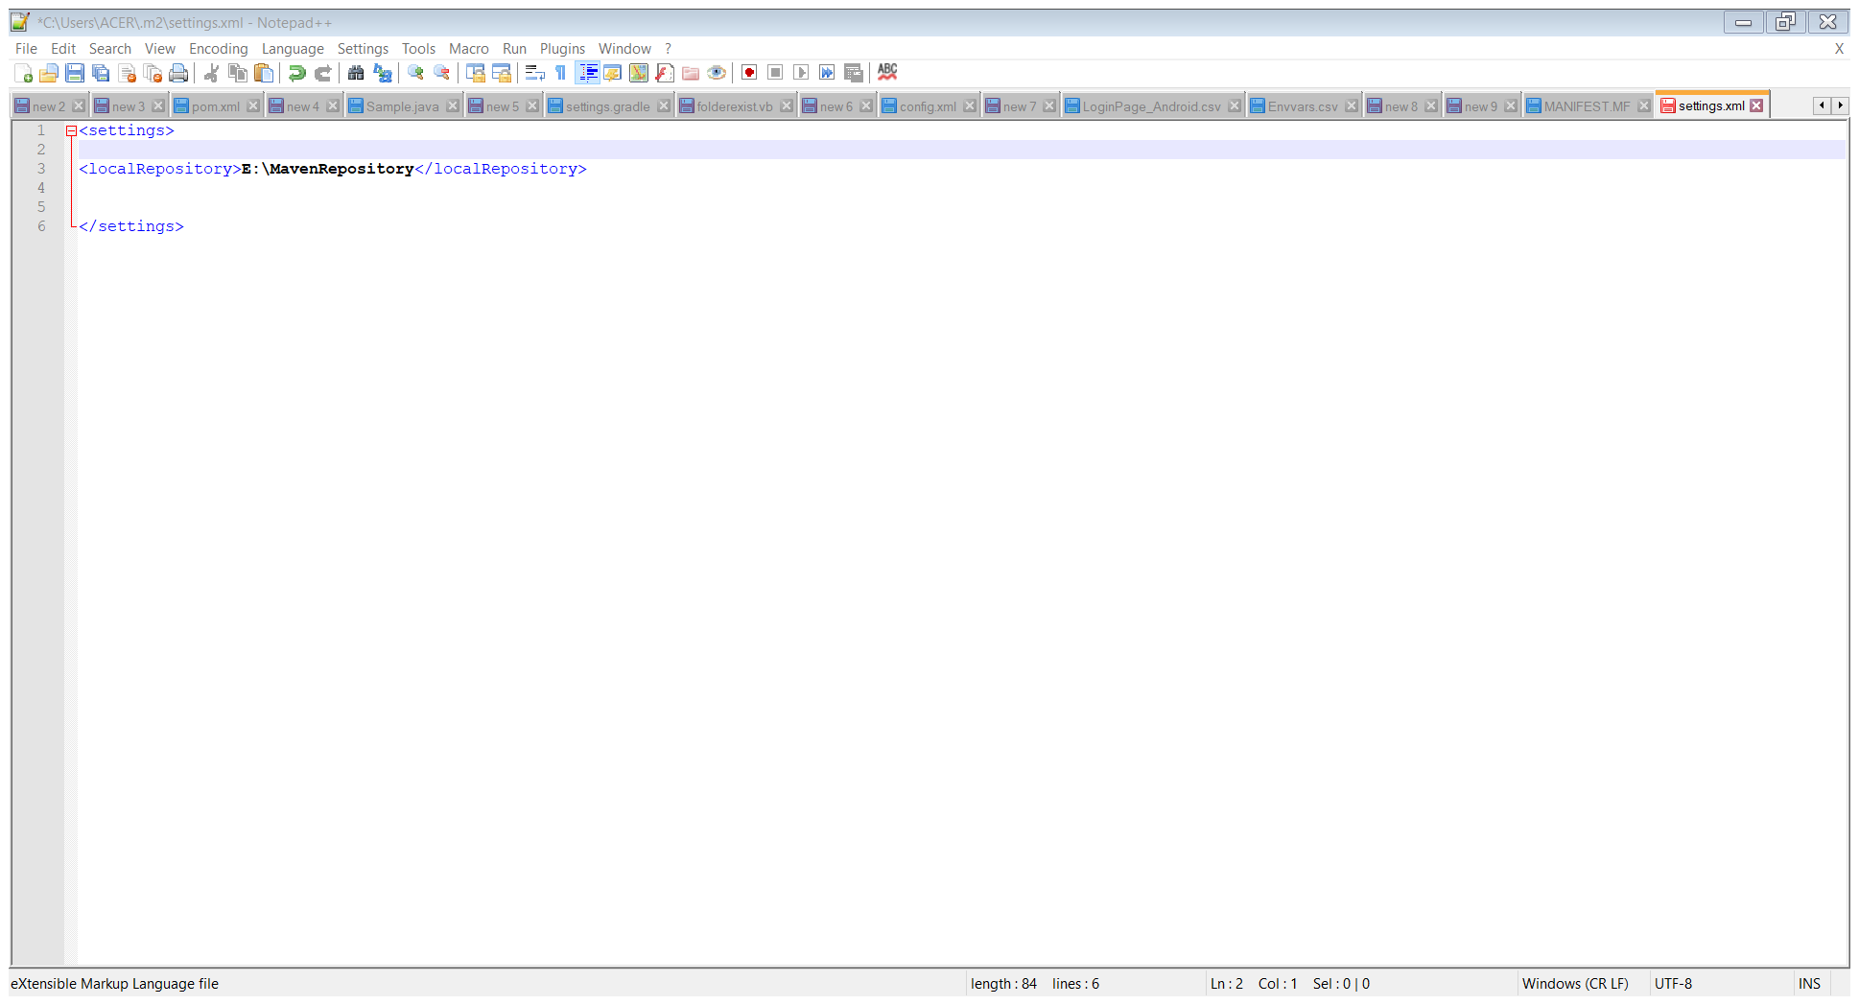

Update the local repository